Normal Distribution Practice

# Systolic blood pressure Dataset

## Range: 115-125

## Average : 120

## Std Deviation: 0.9

* Top 10 percent people range : 121.15 – 125

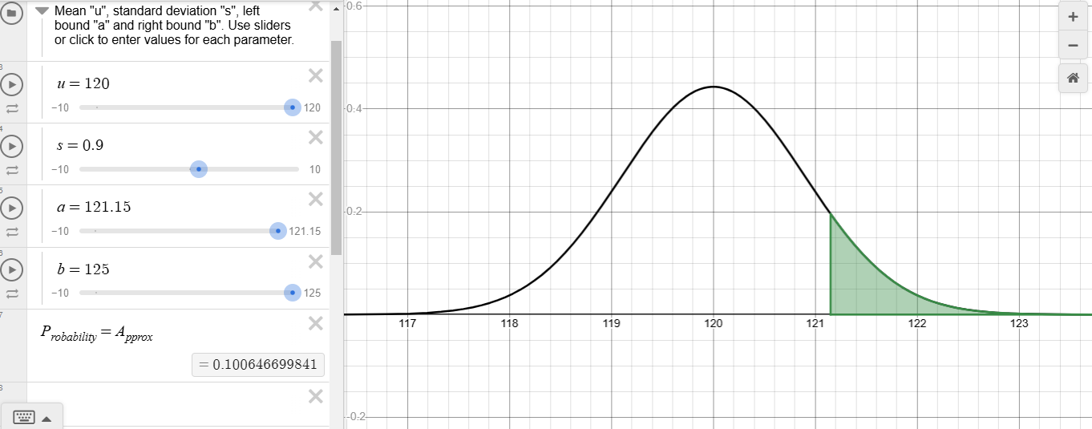

* Bottom 10 percent people range : 115 – 118.85

